Report Name: Annual Review/Reevaluation Due Date Report
Purpose: The purpose of this report is to review Annual Review/Reevaluation Due Dates for students with closed IEPs.
Includes; Student Name; Local ID; Resident County; Resident School; Service County; Service School; Disability; Race; Current Grade; IEP Date; Gender; Nature; Time (Hrs & Minutes); Frequency; Begin Date; End Date; Manner of Delivery
1. The Annual Review/Reevaluation Due Date Report can be filtered by Resident County/School, Service County/School and/or Grade. Also, a range of dates must be selected, they include Most Recent Annual Review Date; Projected Annual Review Date; Most Recent Reevaluation Date; Projected Reevaluation Date, along with a From and to date.
2. To set the From and To date range for this report, the Date Range for Most Recent Annual Review and Most Recent Reevaluation Due Date would be dates in the past. The Project Annual Review Date and Reevaluation Due Date would be dates in the future.


Tip: The search will only yield results for resident and service schools to which the user is assigned.


Note: If the service county and school, as well as, the Resident County and school criteria are selected, the reporting tool will yield a smaller, more specific set of results. Selecting the resident county will produce a report of students within the selected county regardless of Service County. Selecting the service county will produce a report of students within the selected county regardless of Resident County.

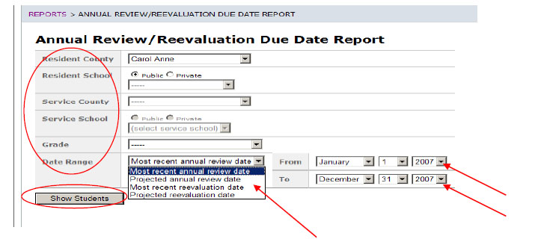

3. After the criteria are selected, a listing of students will appear below the Show Students button

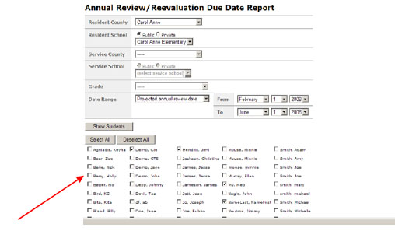

4. Choose which student or students will be included in the Annual Review/Reevaluation Due Date report by clicking on the square check box
next to the desired student’s name.
5. Or, to choose all students, click the Select All button.
6. Next, click the Run Report button.
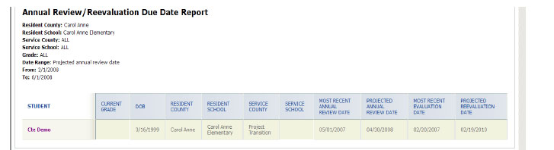

7. The results can be viewed on screen, printed or downloaded to a CSV file.

