Report Name: LRE Report
Purpose: To review LRE placement data in Detail form for an individual or group of students or in Summary form from a school or district perspective.
Detail Reports Include: Student Name; SASID; Local ID; Date of Birth; Resident County; Resident School; Service County; Service School; Disability; Race Current Grade; IEP Date; Gender; LRE

Summary Reports Include: Resident County, Resident School, A-Inside General Education (80% or More), B-Inside General Education (40%-79%), C-Inside General Education (Less Than 40%), D-Homebound, E-Hospital, F-Public Separate Day School, H-Public Residential Facility, I-Private Residential Facility, U-Correctional Facilities, V-Parentally Placed in Private Schools

Part B SPP Indicator 5 Report Includes: Residence County, Residence School, Indicator 5 A-Removed from Regular Class Less Than 21% of the Day, #OF Students, % Of Students in 5A, Indicator 5 B-Removed From Regular Class Greater Than 60% Of the Day, # Of Students in 5B, Indicator 5 C-Served in Public or Private Separate Schools Residential Placements Or Homebound Or Hospital Placements, # Of Students in 5C, # Of Students in 5C, Total students Aged 6-21 With Active IEP.

The LRE Report can be filtered by Resident County/School, Service County/School, Grade, Part C (3-5) Details, Part B (6-21) Details, Part C (3-5) Summary, Part B (6-21) Summary, Part B SPP Indicator 5.


Tip: The search will only yield results for resident and service schools to which the user is assigned.


Note: If both the service county and school, as well as, the resident county and school criteria are selected, the reporting tool will yield a smaller, more specific set of results. Selecting the resident county will produce a report of students within the selected county regardless of service county. Selecting the service county will produce a report of students within the selected county regardless of resident county.

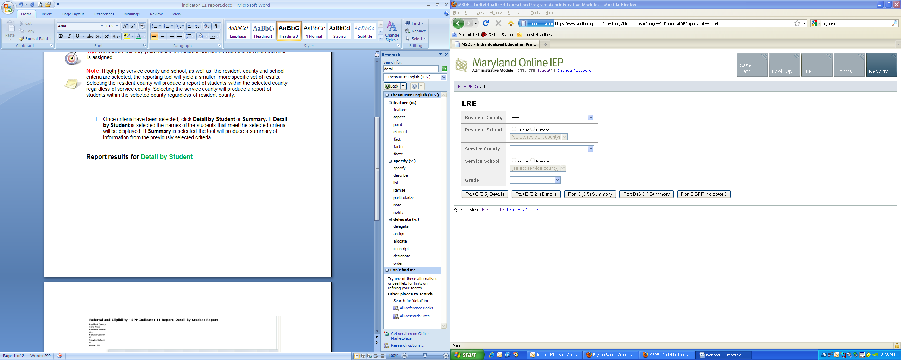

Once criteria have been selected, select one of the five filters at the bottom of the page.

Report results for Part C (3-5) Details or Part B (6-21) Details

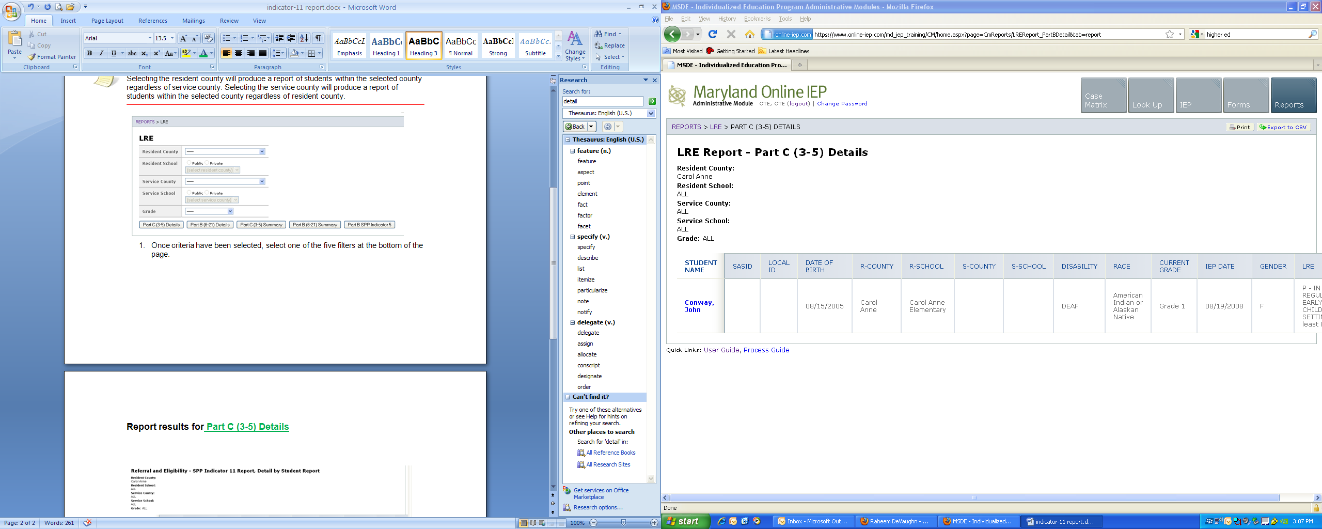

Report results for Part C (3-5) Summary or Part B (6-21) Summary

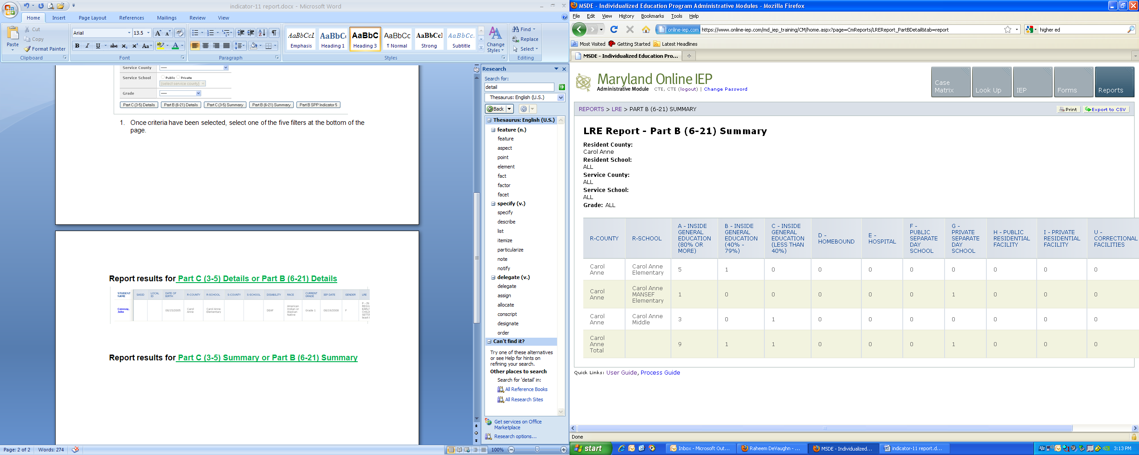

Report results for Part B SPP indicator 5

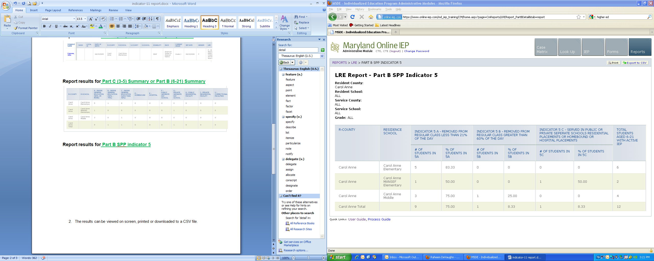

The results can be viewed on screen, printed or downloaded to a CSV file.

