Report Name: Present Levels Report

Purpose: To review area discussion information for individual students or a group of students with closed IEPs.
Includes: Student Name; Local ID; Resident County; Resident School; Service County; Service School; Disability; Race; Current Grade; IEP Date; Gender; Parental Input; Student Strengths; Participation In and Access to General Ed.

The Present Levels Report can be filtered by Resident County/School, Service County/School and/or Grade.
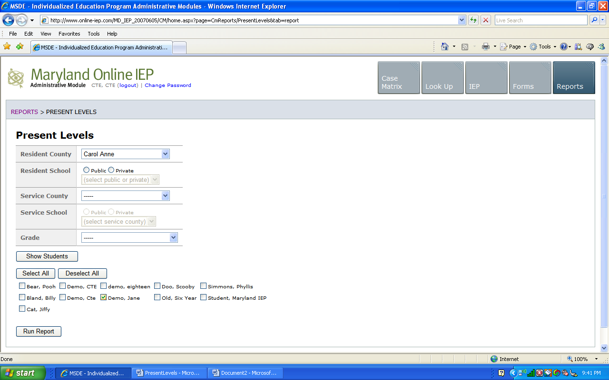


Tip: Notice that the resident county/school fields no longer default to your resident county/school. The search will only yield results for resident and service schools to which the user is assigned.

Once criteria have been selected, click Show Students to view the names of the students that meet the selected criteria.


Note: If the service county and school, as well as, the Resident County and school criteria are selected, the reporting tool will yield a smaller, more specific set of results. Selecting the resident county will produce a report of students within the selected county regardless of Service County. Selecting the service county will produce a report of students within the selected county regardless of Resident County.

- Choose which student or students will be included in the Present Levels report by clicking on the square check box next to the desired student’s name.
- Or, to choose all students, click the Select All button.
- Next, click the Run Report button.

Present Levels Report
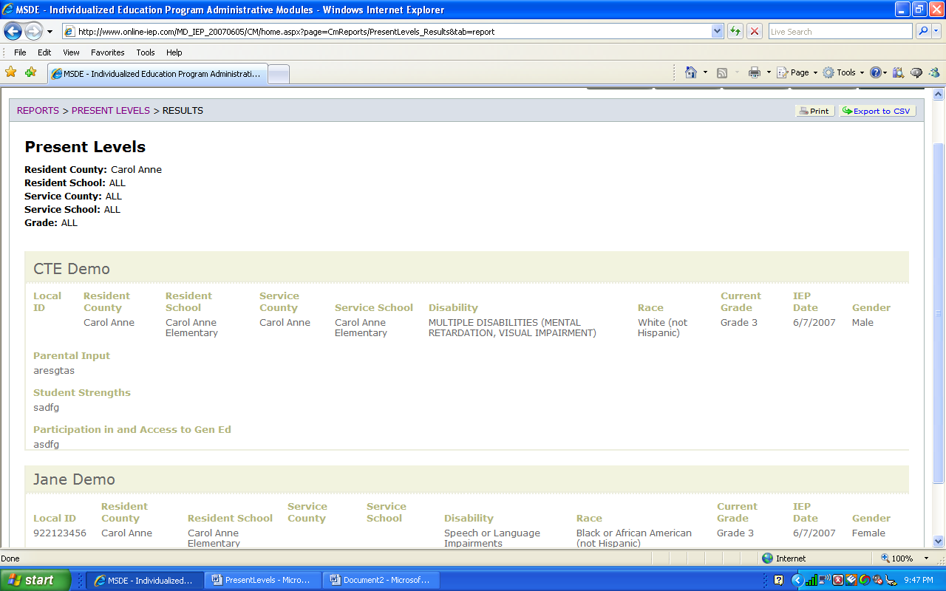
Note: If more than one student is chosen, there will be a page break between each student. At the end of each student’s Present Levels report, the tool forces the next student’s Present Levels report to began on a new page.

The results can be viewed on screen, printed or downloaded to a CSV file (see Downloading to CSV).

