Report Name: Special Considerations Report

Purpose: To review special considerations data for individual students or a group of students with closed IEPs.
Includes: Student Name; Local ID; Resident County; Resident School; Service County; Service School; Disability; Race; Current Grade; IEP Date; Gender; Special Communication Needs; AT Device(s); AT Service(s); Blind or Visually Impaired; Deaf or Hearing Impairment; Behavioral Intervention Plan; Limited English Proficiency

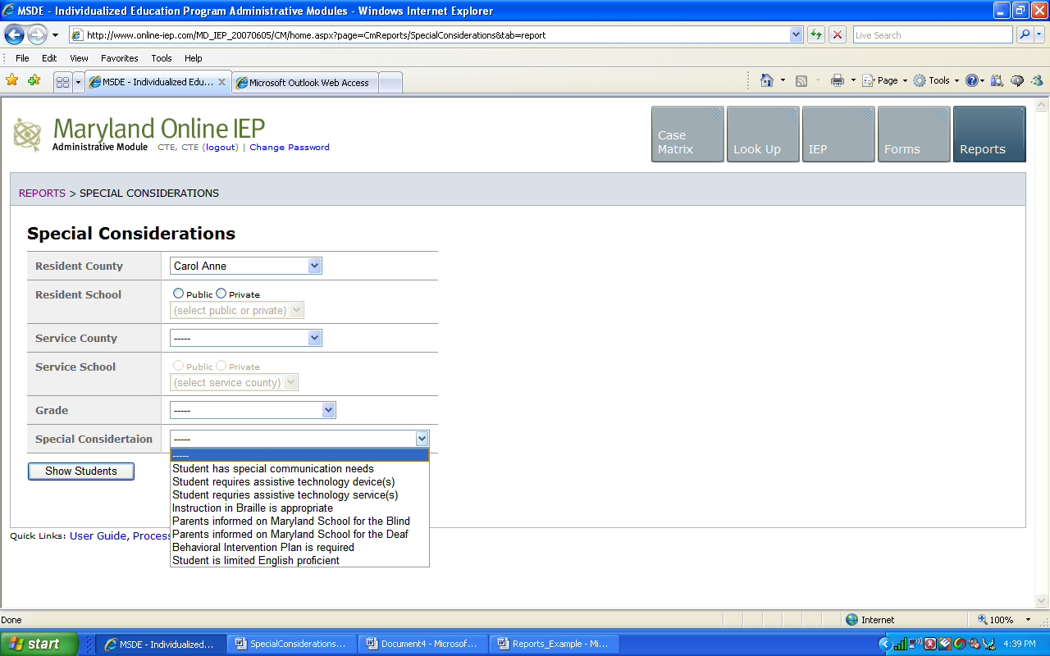
The Special Considerations Report can be filtered by Resident County/School, Service County/School, Grade and/or type of special consideration.


Tip: Notice that the resident county/school fields no longer default to your resident county/school. The search will only yield results for resident and service schools to which the user is assigned.

Once criteria have been selected, click Show Students to view the names of the students that meet the selected criteria.


Note: If the service county and school, as well as, the Resident County and school criteria are selected, the reporting tool will yield a smaller, more specific set of results. Selecting the resident county will produce a report of students within the selected county regardless of Service County. Selecting the service county will produce a report of students within the selected county regardless of Resident County.

- Choose which student or students will be included in the Special Considerations report by clicking on the square check box next to the desired student’s name.
- Or, to choose all students, click the Select All button.

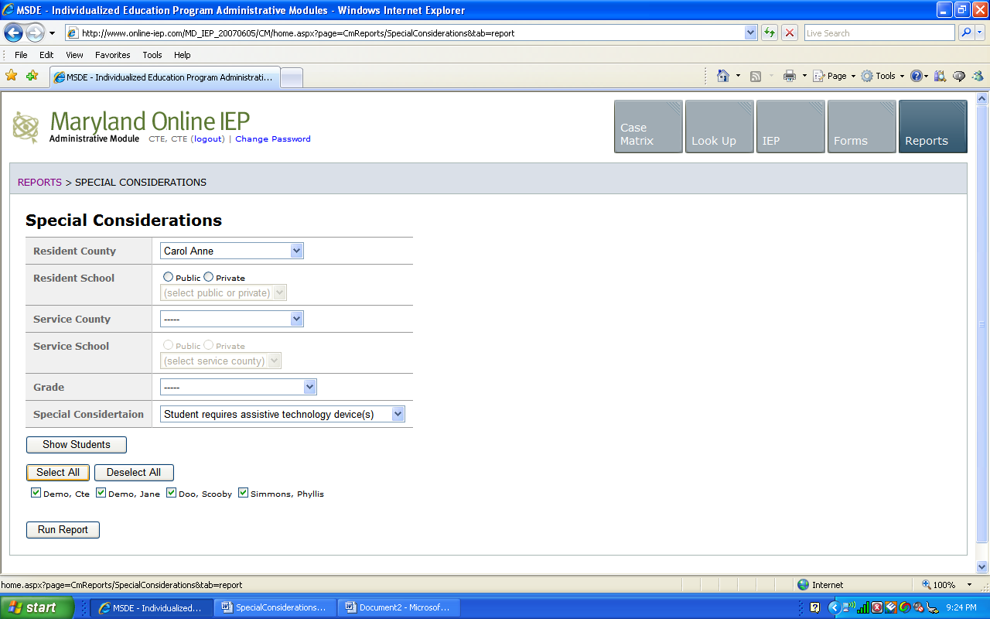

- Next, click the Run Report button.
Note: Details of all the student’s special considerations will be included in the report, but the report will be sorted by the chosen special consideration.

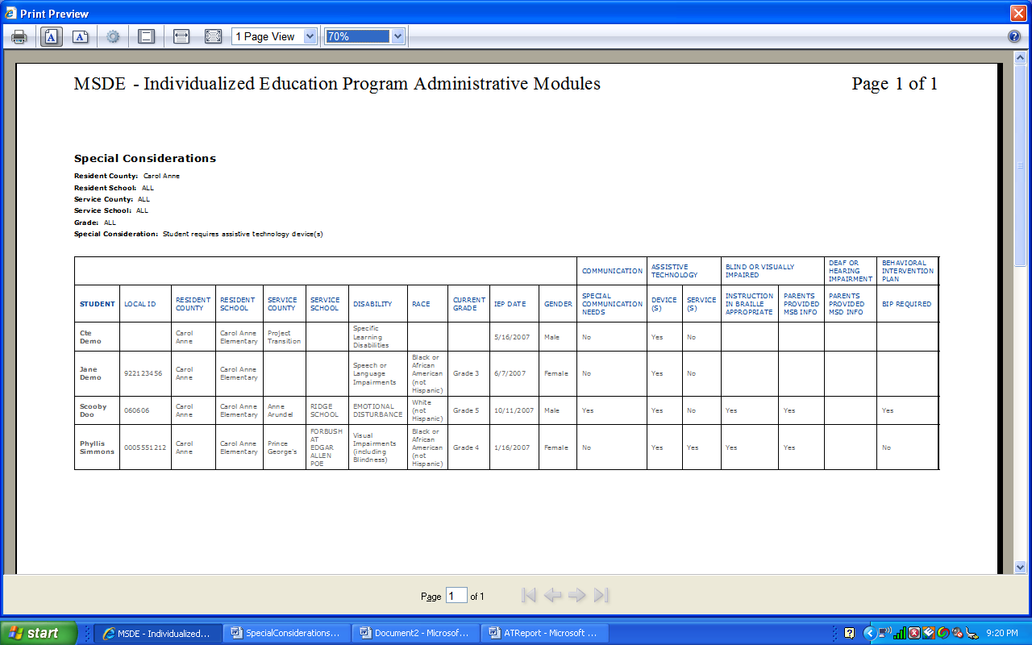
Special Considerations Report

The results can be viewed on screen, printed or downloaded to a CSV file (see Download to CSV).

