Report Name: Exited Report
Purpose: To review exit data for individual students or a group of students with closed IEPs.
Includes: Student Name; Local ID; Resident County; Resident School; Service County; Service School; Race; Sex; Grade; Gender; IEP Date; Exit Date; Exit Reason; Projected Exit Date.

The Exited Report can be filtered by Resident County/School, Service County/School, Grade and/or Exit Date.


Tip: The search will only yield results for resident and service schools to which the user is assigned.

Once criteria have been selected, click Show Students to view the names of the students that meet the selected criteria.

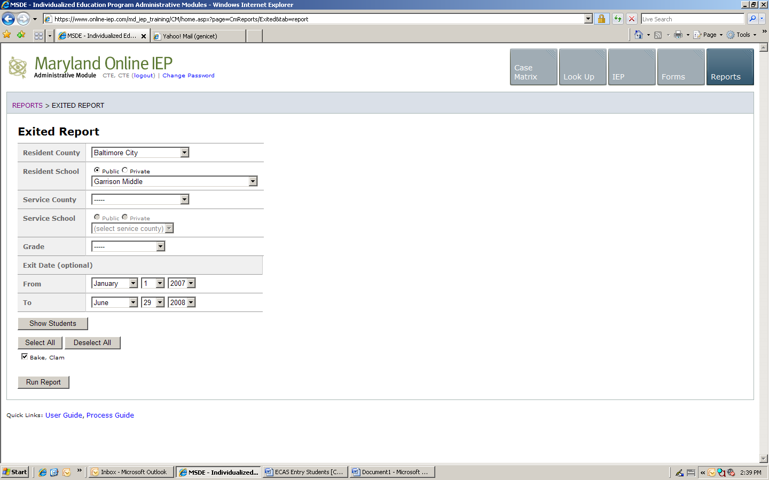
Note: If the service county and school, as well as, the Resident County and school criteria are selected, the reporting tool will yield a smaller, more specific set of results. Selecting the resident county will produce a report of students within the selected county regardless of Service County. Selecting the service county will produce a report of students within the selected county regardless of Resident County.

Choose which student or students will be included in the Exited Report by clicking on the square check box next to the desired student’s name.
- Or, to choose all students, click the Select All button.
- Click Run Report.

The results can be viewed on screen, printed or downloaded to a CSV file (see page XVII-3 – 5).

Exited Report

