Report Name: Initial Eligibility Timeline Report
Purpose: To review the Initial Eligibility Timeline for individuals or a group of students with a completed Notice and Consent for Assessment Form.
Includes: Student Name; Local ID; Date of Birth; Residence County; Residence School; Service County; Service School; IEP Date; IEP In Effect Date; Referral Date Parent Consent For Assessment Date; Evaluation Results Shared No Later Than Date-(up to 90 days from referral or 60 days from parent consent); Assessment Ordered; Form Completed On Date.

Tip: The search will only yield results for resident and service schools to which the user is assigned.


Note: If the service county and school, as well as, the Resident County and school criteria are selected, the reporting tool will yield a smaller, more specific set of results. Selecting the resident county will produce a report of students within the selected county regardless of Service County. Selecting the service county will produce a report of students within the selected county regardless of Resident County.

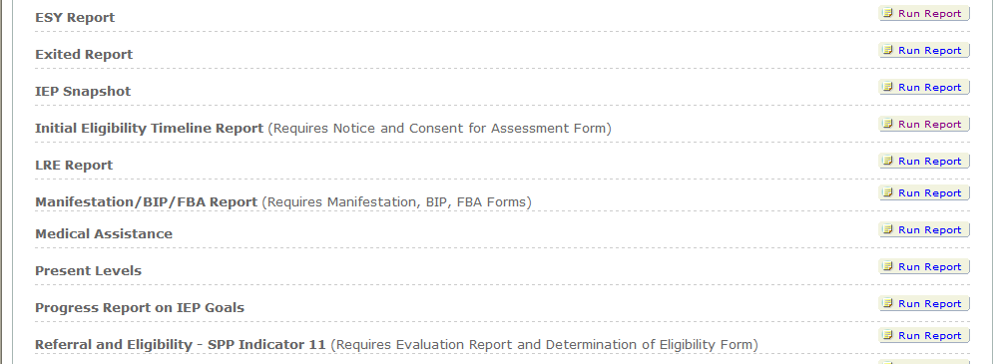

- Choose the Reports button from any screen in the Maryland Online IEP.
- Next, from the list of available reports, choose the Run Report button to the right of the : Initial Eligibility Timeline Report label.
- Then, choose which of the available criteria will be used to filter the report.

NOTE:
A resident county must be chosen to select a resident school (along with a designation of private or public), the same applies when choosing a service county and school. A grade can be chosen independent of resident county/school or service county/school.

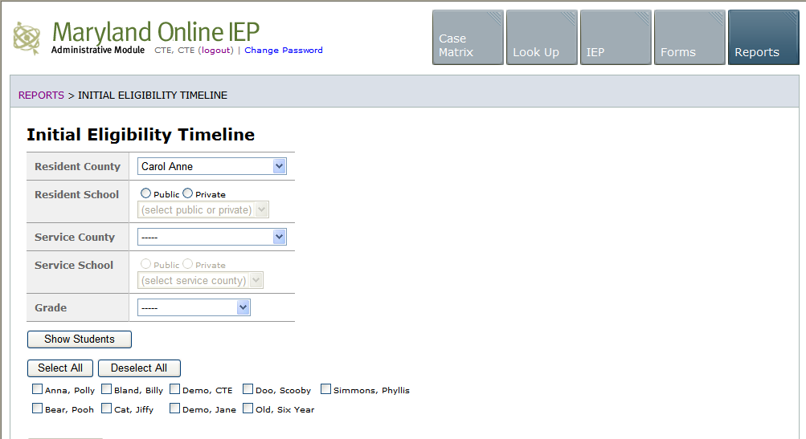

- After the criteria are selected, a listing of students will appear below the Show Students button.
NOTE: Once all reporting criteria have been chosen, the user may choose to run the results by individual student or all students who meet the selected criteria.

- Choose which student or students will be included in the progress report by clicking on the square check box next to the desired student’s name.
- Or, to choose all students, click the Select All button.
- Next, click the Run Report button.

