Report Name: Progress Report on IEP Goals Report
Purpose: The purpose of this report is to review progress toward IEP goals for individual students or a group of students with closed or draft IEPs with goals.
Includes: IEP Type (Closed or Draft with goals); Student Name; Goal(s); Objective(s); Academic and Functional Area Assessed; Evaluation Method; By (Date); with (degree of accuracy); ESY Goal; Progress Code; Description of Progress; Date of Progress Report.
- The progress report on IEP goals can be filtered by IEP Type, Resident County/School, Service County/School and/or Grade.
- Once criteria have been selected, click Show Students to view the names of the students that meet the selected criteria.


Tip: The search will only yield results for resident and service schools to which the user is assigned.


Note: If the service county and school, as well as, the Resident County and school criteria are selected, the reporting tool will yield a smaller, more specific set of results. Selecting the resident county will produce a report of students within the selected county regardless of Service County. Selecting the service county will produce a report of students within the selected county regardless of Resident County.

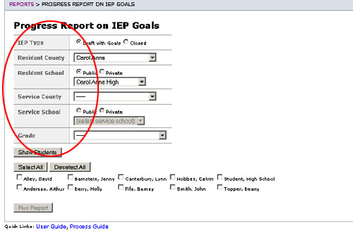
- Choose which student or students will be included in the progress report by clicking on the square check box next to the desired student’s name or to choose all students, click the Select All button. Or, to choose all students, click the Select All button.
- Next, click the Run Report button.
- The results will include the selected student or students’ goals, objectives and progress details. If more than one student is selected, the report will include a page break between each student.

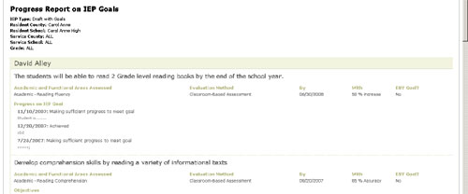

The results can be viewed on screen, printed or downloaded to a CSV file.

