Report Name: Referral and Elgibility—SPP Indicator 11 Report
Purpose: To review referral and eligibility data for individual students or a group of students.
NOTE: The Referral and Elgibility—SPP Indicator 11 Report requires that the Evaluation Report and Determination of Eligibility be completed.
Includes: Student Name; SASID; Local ID; Date of Birth; Resident County; Resident School; Service County; Service School; Disability; Gender; Race Current Grade; Active IEP Date; Date of Referral; Date of Consent for Assessment; Date of Evaluation Determined Eligible: Date Initial IEP is in Effect; # of Days Delayed Beyond 60 Days From Consent; Reason For Delay; Included in Summary

The Referral and Elgibility—SPP Indicator 11 Report can be filtered by Resident County/School, Service County/School, Grade and Parent consent to evaluate date range.


Tip: The search will only yield results for resident and service schools to which the user is assigned.


Note: If both the service county and school, as well as, the resident county and school criteria are selected, the reporting tool will yield a smaller, more specific set of results. Selecting the resident county will produce a report of students within the selected county regardless of service county. Selecting the service county will produce a report of students within the selected county regardless of resident county.

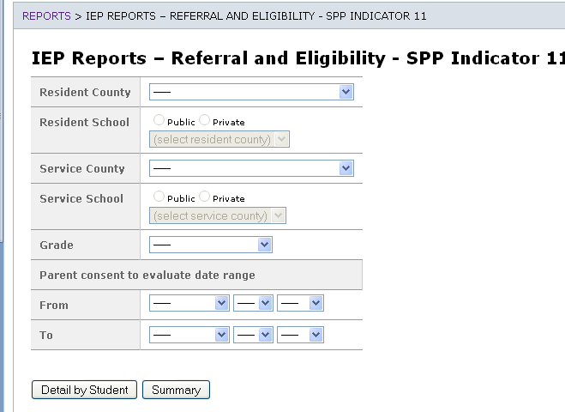

Once criteria have been selected, click Detail by Student or Summary. If Detail by Student is selected the names of the students that meet the selected criteria will be displayed. If Summary is selected the tool will produce a summary of information from the previously selected criteria.

Report results for Detail by Student

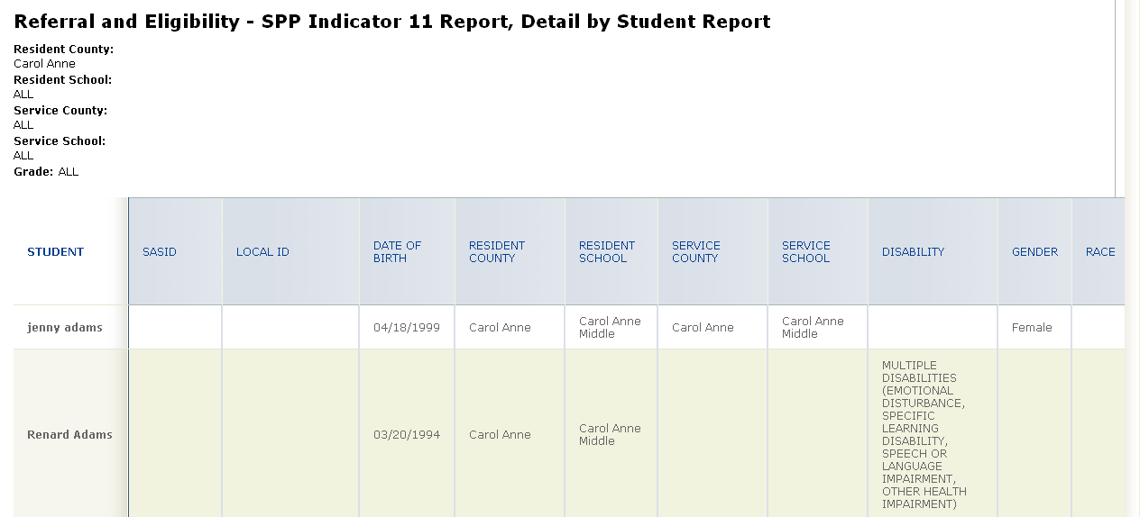

Report results for Summary

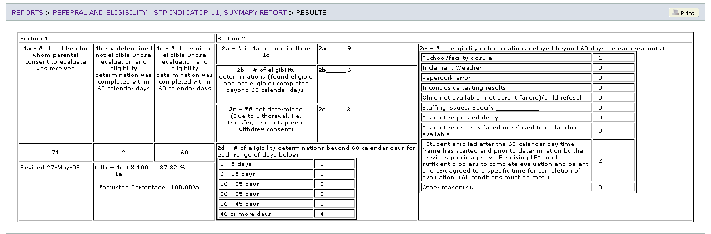

The results can be viewed on screen, printed or downloaded to a CSV file.

