Report Name: Goal Matrix
Purpose: To provide a matrix of student’s goals and objectives to document progress as instruction is provided (data collection).

Includes: Student Name; IEP Meeting Date; Goals; Objectives; Date Fields

The Goal Matrix can be filtered by Resident County/School, Service County/School, or Grade.


Tip: The search will only yield results for resident and service schools to which the user is assigned.

Once criteria have been selected, click Show Students to view the names of the students that meet the selected criteria.
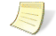
Note: If both the service county and school, as well as, the resident county and school criteria are selected, the reporting tool will yield a smaller, more specific set of results. Selecting the resident county will produce a report of students within the selected county regardless of service county. Selecting the service county will produce a report of students within the selected county regardless of resident county.

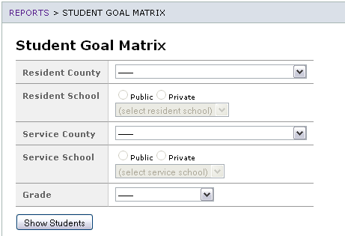

Choose which student or students will be included in the Assessment Report by clicking on the square check box next to the desired student’s name. Or, to choose all students, click the Select All button.
- Click Run Report.

The results can be printed to be completed by the service provider for data collection to document student progress.

Student Goal Matrix

