Report Name: Supplementary Aids, Services, and Program Modifications Report
Purpose: The purpose of this report is to review Supplementary Aids, Services, Supports and Program Modifications data for individual students or a group of students with closed IEPs. This report includes Student Name; Local ID; Resident County; Resident School; Service County; Service School; Disability; Race; Current Grade; IEP Date; Gender; Alt MSA; Mod MSA Reading/Math/ Science; MSA Reading/Math/Science; Mod HSA English/Algebra/Biology; HSA English/Algebra/Biology.
- The Supplementary Aids, Services, Supports and Program Modifications Report can be filtered by Resident County/School, Service County/School and/or Grade.
- Once criteria have been selected, click Show Students to view the names of the students that meet the selected criteria.
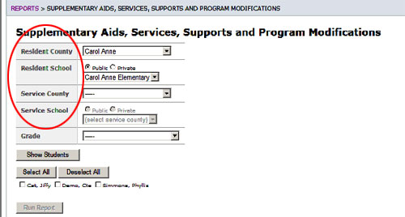


Tip: The search will only yield results for resident and service schools to which the user is assigned.


Note: If the service county and school, as well as, the Resident County and school criteria are selected, the reporting tool will yield a smaller, more specific set of results. Selecting the resident county will produce a report of students within the selected county regardless of Service County. Selecting the service county will produce a report of students within the selected county regardless of Resident County.

- Choose which student or students will be included in the Supplementary Aids, Services, Supports and Program Modifications report by clicking on the square check box next to the desired student’s name.
- Or, to choose all students, click the Select All button.

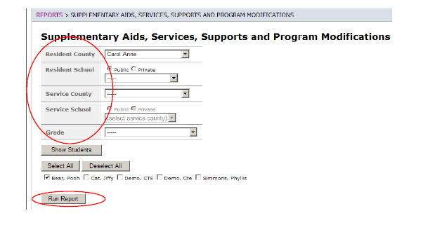
- Next, click the Run Report button
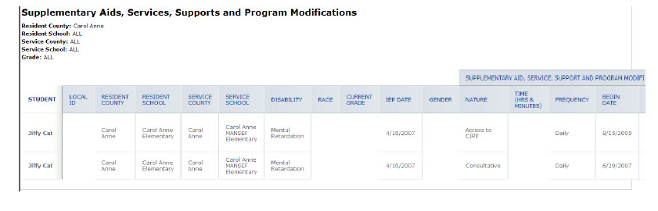

6. The results can be viewed on screen, printed or downloaded to a CSV file

