Report Name: Transition Report
Purpose: The purpose of this report is to review transition data for individual students or a group of students with closed IEPs.
This report includes: Student Name; SASID; Local ID; Resident County & School; Service County & School; Disability; Race; Current Grade; IEP Date;
Gender; Academic and Functional Areas Assessed; Evaluation Method-By-With; ESY Goal; Objectives; Student Preferences And Interests; Post Secondary Goals (Outcomes); Course of Study; Projected Category of Exit; Agency Linkage; Document basis for decisions.
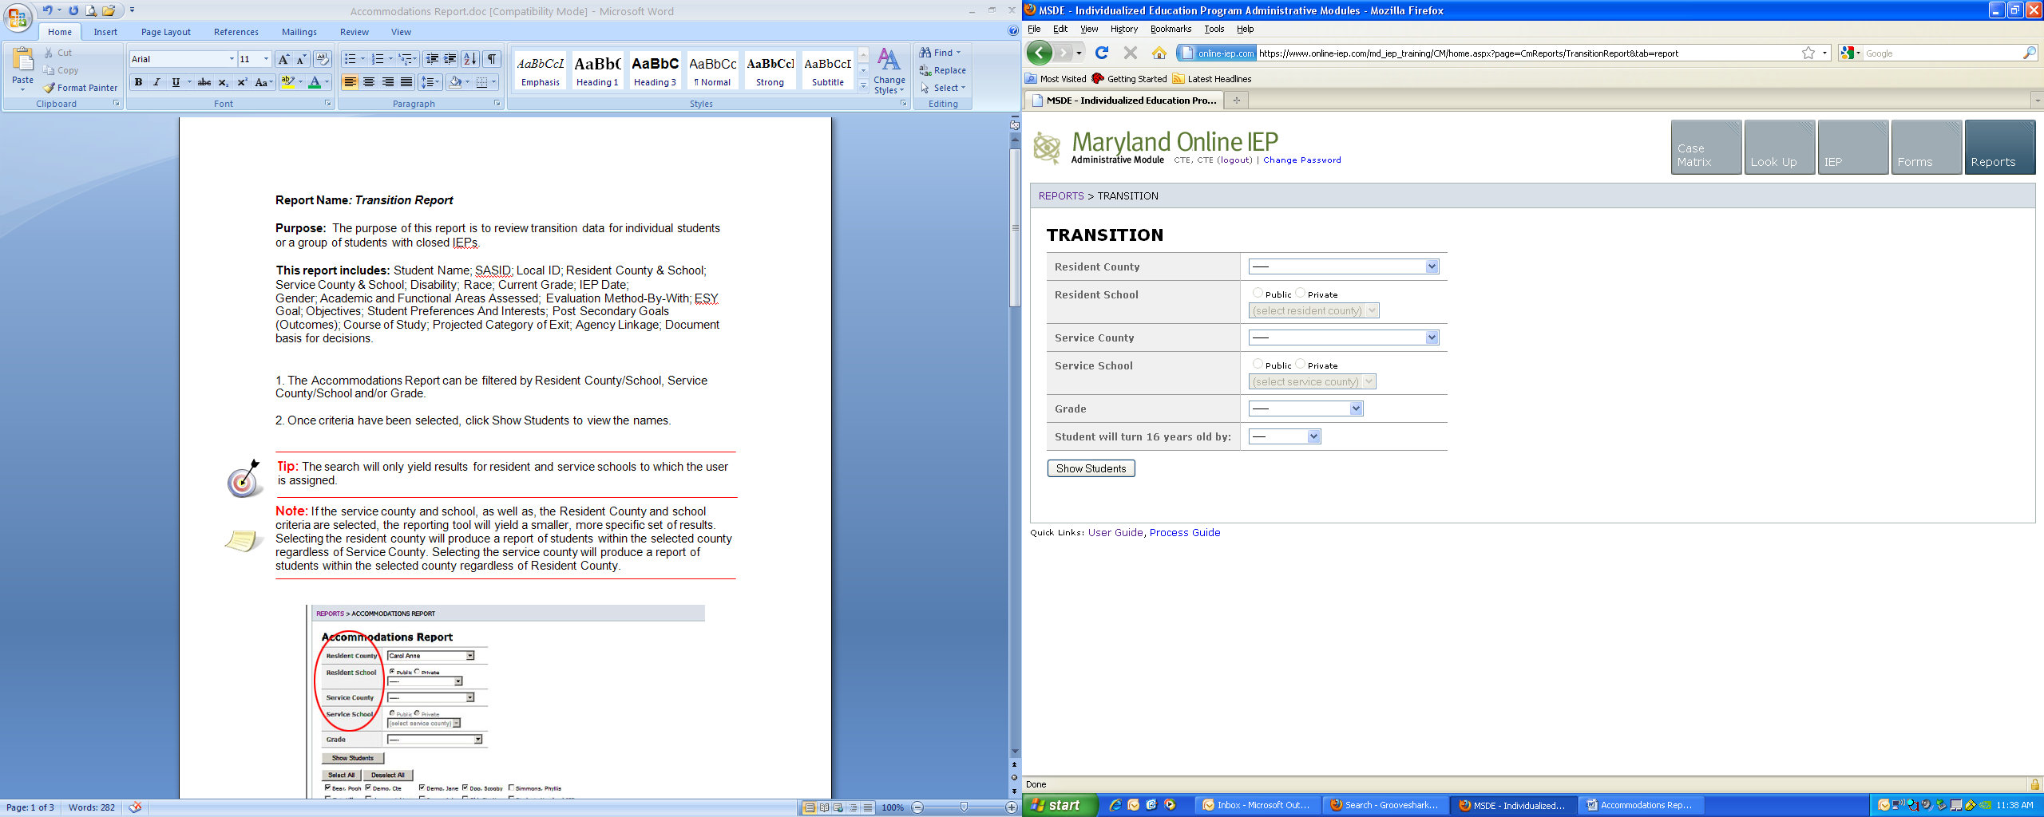
1. The Transition Report can be filtered by Resident County/School, Service County/School, Grade and or Student will turn 16 years old by.
2. Once criteria have been selected, click Show Students to view the names.


Tip: The search will only yield results for resident and service schools to which the user is assigned.


Note: If the service county and school, as well as, the Resident County and school criteria are selected, the reporting tool will yield a smaller, more specific set of results. Selecting the resident county will produce a report of students within the selected county regardless of Service County. Selecting the service county will produce a report of students within the selected county regardless of Resident County.

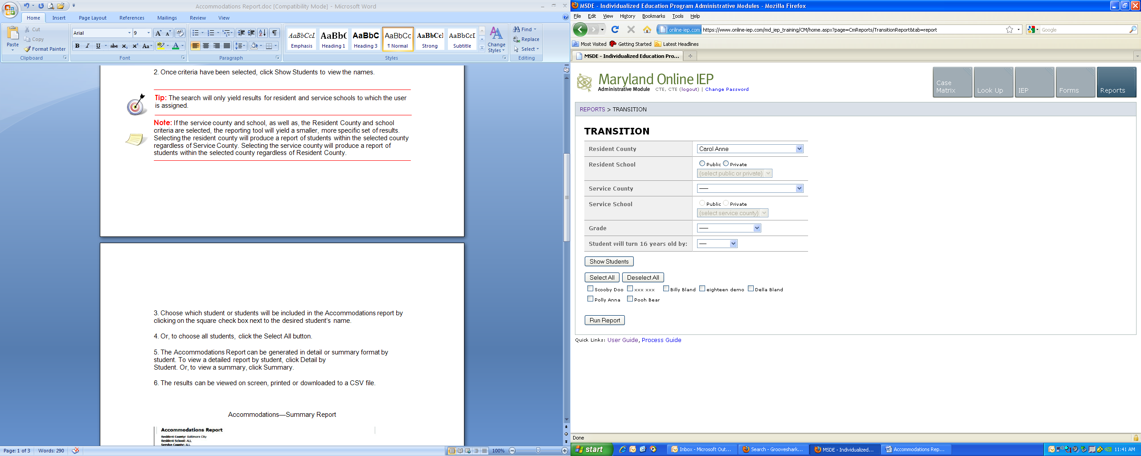

3. Choose which student or students will be included in the Transition report by clicking on the square check box next to the desired student’s name.
4. Or, to choose all students, click the Select All button.
5. If the Select All button is chosen, then Run Report, the tool will produce reports for every student that meets the criteria. If the user selects one or more boxes from the list the Transition Report will generate a report for the student or students selected.
6. The results can be viewed on screen, printed or downloaded to a CSV file.
Transition Report
