Report Name: User Report
Purpose: The purpose of this report is to review user levels and privileges. This report includes: IEP User, User School, Additional School; User Group;
Admin Access; Can Edit Cases; Can Create Child
1. The User Report can be filtered by County, User Group, School, School Name, Admin Access, Can Edit Cases, Can Create Child.


Tip: The search will only yield results for resident and service schools to which the user is assigned.

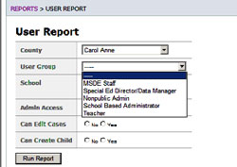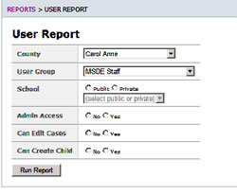
2. Once criteria have been selected, click the Run Report button.
3. The results can be viewed on screen, printed or downloaded to a CSV file.
